Electronic Products and Solutions Group

PGU
SPD
Webdoc Version of document:
Author:
Anurag Dhar
Debug, Release and Exception Message Handler
Design


Not yet entered

1 Purpose: 2
2 Scope: 2
3 Software Design 2
3.1 Design (Major Classes and Block Diagram) 2
3.1.1 Debug Message Handling 2
3.1.2 Release Message Handling 6
3.1.3 Exception Handling and messaging 9
3.1.4 Trace Listners 13
3.1.5 Enums 16
3.1.6 Constants 17
3.1.7 Utils 17

Purpose:
The purpose of this document is to describe the Debug, Release and Exception Handler design.

Scope:
The scope of this document is describing the Debug, Release and Exception handler Design and usage.

Software Design
This section describes the software architecture.

Design (Major Classes and Block Diagram)
This section describes the high level software architecture and the associated responsibility of the classes.

Debug Message Handling

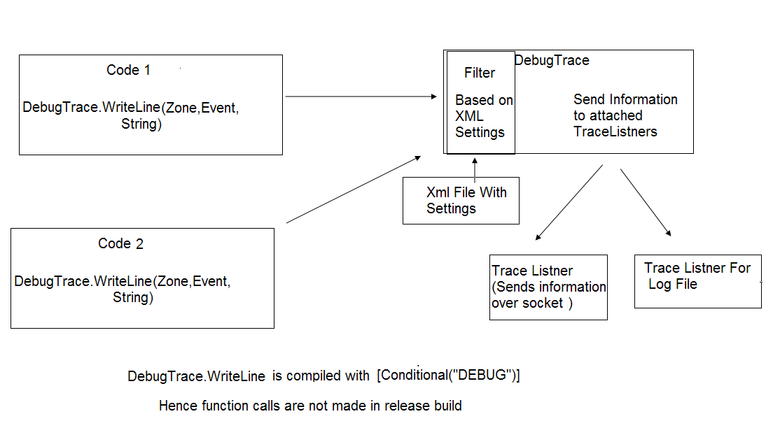

The developers need to put some messages in the code to track the behavior of their code.
The common practice is putting the Debug.Assert, MessageBox and LogFileWrite.
The disadvantages with these methods are that mode of trackking is hard coded(one can only use logFile /Assert/Message box not all or in combination) and once embedded in the code we can’t make selective debugging .i.e. if we put 100 MessageBoxes/LogFileWrite calls inside our code then either all are active or all are disabled, we can’t have selection over debug information.

In the Given block Diagram the developer needs to call DebugTrace.WriteLine(Zone,Event)/or DebugTrace.WriteLine(BOOL , Zone,Event) in the code.By making this call the developer becomes independent of the receiver.
The DebugTrace class filters the call on the basis of Zone ,Event Type and send information to attached listners derived from the TraceListner Class.

Debug Trace Class

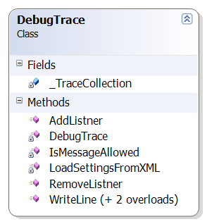

The DebugTrace class handles debug related detail/capabilites of the application.This class gives overloaded WriteLine function which is called by users to put debug messages.This method might be getting called from many places.Thus to limit the debugging information we are using an xml file which contains various settings like which module call should be passed/dropped.The DebugTrace class loads these settings and then pass/drop message calls depending on these settings. As the number of calls are more and require faster searching of Datastructure. We Will be using Data structure like Array to store the filtering information for faster decision making. Apart from that this method will be called from multiple threads.

The responsibilities of this class will be:
- Provide user with a function to send debug related information.
- Use conditional debug characterstric to put call off during DebugMessage characterstics of the WinCe and platform build to dignose any unexpecterd behaviour.
- A single point for user to put his debug related message.

Features:-
- This Class will be containing several staticmethods.
- The developers will be using public static void WriteLine method
- The method writeLine will be compiled with the conditional debug option.Hence making this function call available only for debug builds hence we will save time spent in function call in release mode .
- The options for the DebugTrace settings are loaded from the XML file.Hence the user can control most of the functionality of this class by making simple changes in the xml file.

Major Data Members and functions of the class:-

Public Member Variables:-
none
Private Member Variables:-
private static TraceCollection _TraceCollection;

Public Member functions:-

public static void AddListner(TraceListener oTraceListener)
public static void RemoveListner(TraceListener oTraceListener)
public static void WriteLine(bool bWrite,enumEventModule eModuleType, enumEventType eEventType, string message)
public static void WriteLine(enumEventModule eModuleType, enumEventType eEventType, object obj)
public static void WriteLine(enumEventModule eModuleType, enumEventType eEventType, string message)

Private Member functions:-
private static bool IsMessageAllowed(enumEventModule eModuleType, enumEventType eEventType)
This function will check the if the message has to be placed for the TraceListners

private void LoadSettingsFromXML()
This function will load the debug related settings from the DebugConfig.Xml file

DebugConfig.XML
The sructure of xml file will be like this.
<DebugConfig>
<MasterDebugSwitch name="Master Debug Switch" enumValue ="eMasterDebugSwitch" Value ="eON" Description ="Used as a master switch for Debug option">
</ MasterDebugSwitch >
<ModuleEventSettings>
<Module name="TraceCtrlModuleEvent" enumValue ="eTracetrl" Value ="eON" >
<Event name ="Enter Function " enumValue ="eEnterFunction" Value ="eON" ></Event>
</Module>
<Descriptions>
<WriteThreadID ThreadID= "eOn" Description ="Write desc here">
</WriteThreadID>
<WriteTime Time="eOn" Description ="Write desc here">
</WriteTime>
<WriteModuleName ModuleName= "eON" Description ="Write desc here">
</WriteModuleName>
<WriteEventName EventName="eON" Description ="Write desc here">
</WriteEventName>
</Descriptions>

</DebugConfig>

Release Message Handling

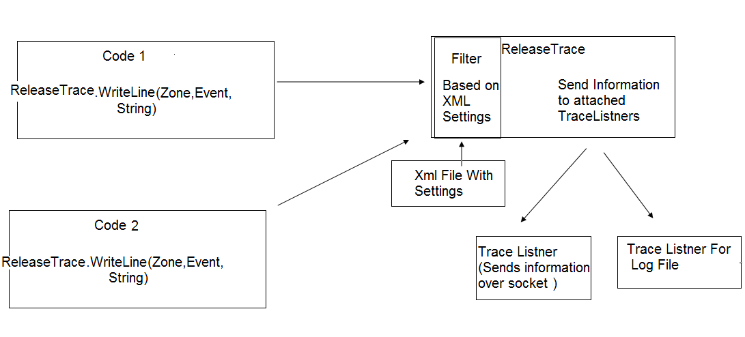

The developers need to put some messages in the code to track the behavior of their code in release time.
The common practice is using the function call to write in the LogFile.

The disadvantages with this method are that mode of trackking is hard coded(only logFile)
and once embedded in the code we can’t make selective Logging.i.e. if we put 100 LogFileWrite calls inside our code then either all are active or all are disabled, we can’t have selection over logging information.

In the Given block Diagram the developer needs to call ReleaseTrace.WriteLine(Zone,Event)/or ReleaseTrace.WriteLine(BOOL , Zone,Event) in the code.By making this call the developer becomes independent of the receiver media
The releaseTrace class filters the call on the basis of Zone and Event Type and send information to attached listners derived from the TraceListner Class.

ReleaseTrace Class

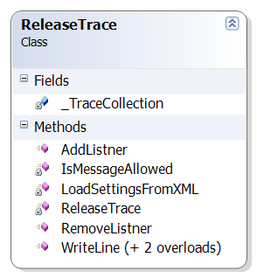

The ReleaseTrace class handles release message related detail/capabilites of the application.This class gives WriteLine function which is called by users of this class to pass their release messages.This method will be called by many users.Thus to limit the information we are using an xml file which contains various settings like which module call should be passed/dropped.The ReleaseTrace class loads these settings from xml and then pass/drop message calls depending on these settings.

The responsibilities of this class will be:
- Provide user with a function to send release message related information.
- A single point for user to put release message related information.

Features:-
- This Class will be containing static methods hence no need to create object for message sending.
- The developers will be using public static void WriteLine method
- The options for the ReleaseTrace settings are loaded from the XML file.Hence the user can control most of the functionality of this class by making simple changes in the xml file.

Major Data Menbers and functions of the class:-

Private Member Variables:-
private static TraceCollection _TraceCollection;

Public Member functions:-

public static void AddListner(TraceListener oTraceListener)
public static void RemoveListner(TraceListener oTraceListener)
public static void WriteLine(bool bWrite,enumEventModule eModuleType, enumEventType eEventType, string message)
public static void WriteLine(enumEventModule eModuleType, enumEventType eEventType, object obj)
public static void WriteLine(enumEventModule eModuleType, enumEventType eEventType, string message)

Private Member functions:-
private static bool IsMessageAllowed(enumEventModule eModuleType, enumEventType eEventType)
This function will check the if the message has to be placed for the TraceListners

private void LoadSettingsFromXML()
This function will load the release message related settings from the Xml file

ReleaseConfig.XML

The structure of XML for Release message filter file will be as :-
<?xml version="1.0" encoding="utf-8" ?>
<ReleaseConfig>
<MasterLogSwitch name="Master Log Switch" enumValue ="eMasterLogSwitch" Value ="eON" Description ="Uset as a master switch for logging option">
</MasterLogSwitch>
<ModuleEventSettings>
<Module name="TraceCtrlModuleEvent" enumValue ="eTracetrl" Value ="eON" >
<Event name ="ExceptionEvent" enumValue ="eException" Value ="eON" ></Event>
</Module>
</ModuleEventSettings>
<Descriptions>
<WriteThreadID ThreadID= "eOn" Description ="Write desc here">
</WriteThreadID>
<WriteTime Time="eOn" Description ="Write desc here">
</WriteTime>
<WriteModuleName ModuleName= "eON" Description ="Write desc here">
</WriteModuleName>
<WriteEventName EventName="eON" Description ="Write desc here">
</WriteEventName>
</Descriptions>

</ ReleaseConfig>

Exception Handling and Messaging

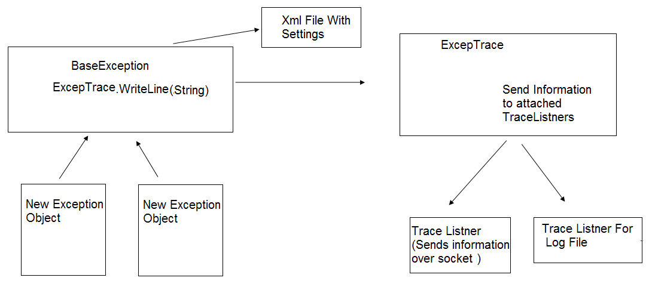

All exceptions types in the applicaion will be derived from a common abstract base class for exception.
The hierarchy of exception will be extended later on.

BaseException Class

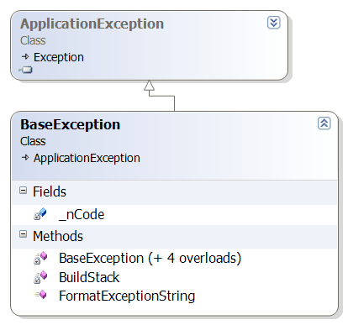

Base exception class is derived from the Application Exception class. The Application Exception class is a .net class that provides some common functionality to exceptions in an application.

The constructor of exception class also takes errorcode as input .

To log exceptions that are not derived from the BaseException user can create a new BaseException class object with given exception as its inner exception.

The responsibilities of this class will be:
- Act as a base class for all exception classes.
- Formatting exception messages to be sent
- Creating Trace Messages as per Formatting
- Provides Tread safe message to create and format trace messages

ExcepTrace Class

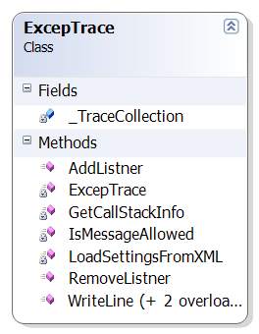

Excep trace class will work and provide the functioanlity in the same way as DebugTrace and Release Trace.

ExcepConfig.XML

<?xml version="1.0" encoding="utf-8" ?>

<MasterLogSwitch name="Master Log Switch" enumValue ="eMasterLogSwitch" Value ="eON" Description ="Uset as a master switch for logging option">
</MasterLogSwitch>
<ModuleEventSettings>
<Module name="TraceCtrlModuleEvent" enumValue ="eTracetrl" Value ="eON" >
<Event name ="ExceptionEvent" enumValue ="eException" Value ="eON" ></Event>
</Module>
</ModuleEventSettings>

<ExceptionDetails>
<WriteCallStack CallStack="eON" CallStackDepth="4" Description ="Write desc here">
</WriteCallStack>
<WriteProcessID PocessID="eON" Description ="Write desc here">
</WriteProcessID>
<WriteThreadID ThreadID= "eOn" Description ="Write desc here">
</WriteThreadID>
<WriteTime Time="eOn" Description ="Write desc here">
</WriteTime>
<WriteModuleName ModuleName= "eON" Description ="Write desc here">
</WriteModuleName>
<WriteEventName EventName="eON" Description ="Write desc here">
</WriteEventName>
</ExceptionDetails>

TraceCollection

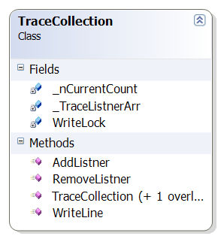
Tracecollection class represents a collection of trace which stores and maintain the trace collection.
User can Add and Remove tracelistners in this class and call writeline on the trace listners in the collection.

Trace Listners

LocalLogListner

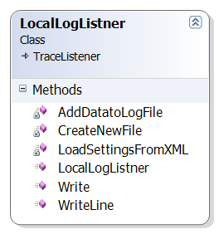

LocalLogListner is derived from the TraceListner. LocalLogListner can be attached to any class which sends the Message to TraceListner class.The functionality of LocalLogListner is customized by the xml file.
LocalLogListner receives the log messages and put them in the log file.The log file size and count created by the LocalLogListner LogHandler class can vary depending on the xml file settings.
This class starts writing onto one log file and once the max size of the log file is reached the next log file is created and log data is written there.Once the count of log file has crossed the maxium count , the one created previously is deleted and files are renamed accordingly. (Note: In case we need better perfomance we can use another variant LocalLogListener wich uses the buffer to write to file.)

The responsibilities of this class will be:
- Creates LogFiles to dump the user data based on the xml setting.

LocalLogConfig.XML

<?xml version="1.0" encoding="utf-8" ?>
<LogFileSettings>
<LogFileSize LogFileSize = "100" Description ="LogFileSize in Kb before starting a new file">
</LogFileSize>
<LogFileCount LogFileCount= "3" Description ="Number of LogFiles to keep before overwriting first create">
</LogFileCount >
<LogFileWritingMode WritingMode ="eBinary" Description ="Write desc here">
</LogFileWritingMode>
<LogFileStoragePath FilePath = "Flash/My Folder/Storehere" Description ="Write desc here">
</LogFileStoragePath>
<LogFileName LogFileName = "MyLog.dat" Description ="If binary mode then this xml will be required to retrive the inforation">
</LogFileName>

</LogFileSettings>

.

LocalSocketListner

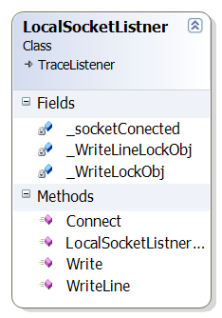

LocalSocketListner class is derived from the TraceListener class. It overrides two functions of TraceListener Class namely Write and WriteLine.The LocalSocketListner loads its settings from the XML document which contains socket settings like IPAddress,Port number etc.Hence we can totally customize its operation without rebuilding it.
The responsibilities of this class will be:
- Read socket related settings from the XML Document
- Receive the trace messages.
- Establish socket Connection to the socket Server.
- Send the Trace messages to the remote server on lan .

SocketConfig.XML

<?xml version="1.0" encoding="utf-8" ?>
<LocalSocketListnerConfig>
<LocalSocketListnerSwitch name="Remote Socket Switch" enumValue ="eLocalSocketListnerSwith" Value ="eON" Description ="Used as a master switch foroption">
</LocalSocketListnerSwitch>
<RemoteIPAddress RemoteIPAddress = "127.0.0.1" Description ="RemoteIPAddress to connect"></RemoteIPAddress>
<RemotePort RemotePort = "1024" Description ="Remote port to connect"></RemotePort>
<AddressFamily enumType ="AddressFamily" Value ="InterNetwork" ></AddressFamily>
<SocketType enumType ="SocketType" Value ="Stream" ></SocketType>
<ProtocolType enumType ="ProtocolType" Value ="Tcp" ></ProtocolType>
</LocalSocketListnerConfig>

Enums

We will be using these major enums in the application.
public enum enumEventModule
{
eTracetrl = 1,
eMeasurement = 2,
eSignal = 3,
eMisce = 4
};

public enum enumEventType
{
eEnterFunction= 1,
eLeaveFunction = 2,
eNativeCall = 3,
eNullReturned = 4,
eInfo = 5,
eObjectState = 6
};
public enum enumState
{
eOn,eOff
};

Enums enumEventModule is used in EVC++ dll and the C# project,Hence any modification at one place should be folowed by the modification at other place.

Constants
Connstants will be a static class containing static readonly data members.The objective of creating this class is to put all string,integer constants used in project at a single place and avoid hard coding.
internal static class Constants
{
public static readonly string DEBUG_SETTINGS_XML_FILE_PATH = "windows/DebugConfig.xml";
public static readonly string RELEASE_SETTINGS_XML_FILE_PATH = " windows/LogConfig.xml ";
public static readonly string EXCEP_SETTINGS_XML_FILE_PATH = " ";
public static readonly string SOCKET_TRACE_LISTNER_FILE_PATH = " ";
public static readonly string LOG_FILE_TRACE_LISTNER_FILE_PATH = " ";

}

Utils

Utils will be a static class containing static methods .The objective of ths class is to identify the common functions in the system and putting them at one place.
internal static class Utils
{
public static XmlDocument GetXMLDocumentFromXMLFile(String FilePath)
{
FileStream stream = null;
XmlDocument xDoc = null;
try
{
stream = new FileStream(Constants.DEBUG_SETTINGS_XML_FILE_PATH, FileMode.Open, FileAccess.Read);
XmlTextReader oXMLReader = new XmlTextReader(stream);
oXMLReader.WhitespaceHandling = WhitespaceHandling.None;
xDoc = new XmlDocument();
xDoc.Load(oXMLReader);

}
catch(System.IO.IOException e )//write code to handle exceptions like file not available,XMLDocument errors
{
//MessageBox.Show(e.Message);
//Debug.Assert(false);
}
finally
{
if (stream!= null)
stream.Close();
}
return xDoc;
}
}

